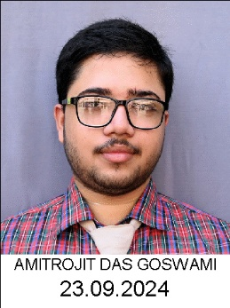  1. AMITROJIT DAS GOSWAMI-96.2% | 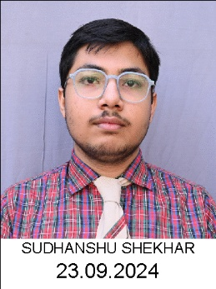  2. SUDHANSHU SHEKHAR-96.2% | 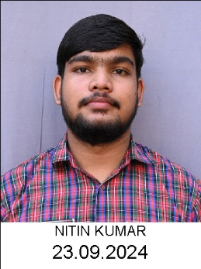  3. NITIN KUMAR-93.2% | 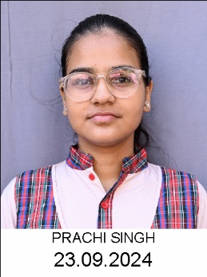  4. PRACHI SINGH-92.8%
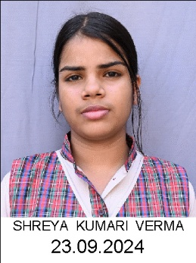  5. SHREYA KUMARI VERMA-92.2% | 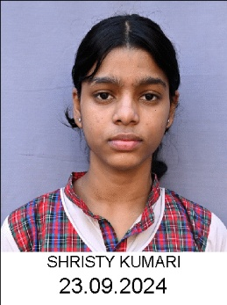  6. SHRISTY KUMARI-91.4% | 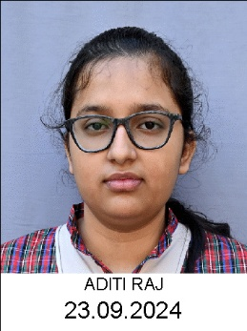  7. ADITI RAJ-91.0% | 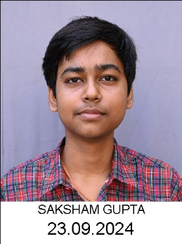  8. SAKSHAM GUPTA-90.6%.jpg
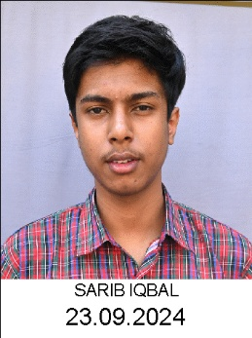  9. SARIB IQBAL-90.0% | 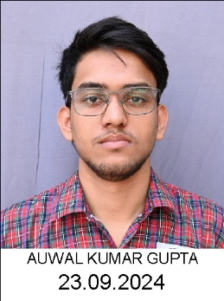  10. AUWAL KUMAR GUPTA-90.0% | 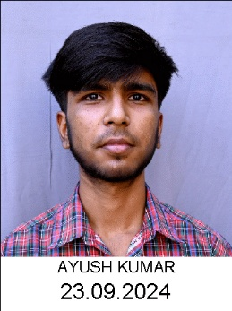  11. AYUSH KUMAR-90.0%
DAV PUBLIC SCHOOL,KOYLANAGAR
90% and Above in SSCE-2025-26
🏆 (Science Stream) 🏆

🏆 🏆

